Программирование позиционных игр. Крестики-нолики

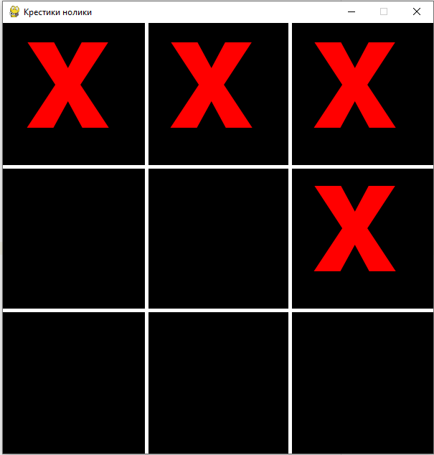import pygame  
from pygame import display, init, draw, event, MOUSEBUTTONDOWN, font  
  
init()  
font.init()  
  
SIZE = (600, 600)  
  
SCREEN = display.set_mode(SIZE)  
display.set_caption("Крестики нолики")  
  
draw.line(SCREEN, 'white', (200, 0), (200, 600), 5)  
draw.line(SCREEN, 'white', (400, 0), (400, 600), 5)  
  
draw.line(SCREEN, 'white', (0, 200), (600, 200), 5)  
draw.line(SCREEN, 'white', (0, 400), (600, 400), 5)  
display.update()  
font = font.SysFont('Сourier New', 320)  
  
  
def draw_char(x, y):  
 x //= 200  
 y //= 200  
 char_render = font.render('x', True, 'red')  
 SCREEN.blit(char_render, (x * 200 + 30, y * 200 - 30))  
 display.update()  
  
  
while True:  
 for e in event.get():  
 if e.type == pygame.QUIT:  
 exit()  
 if e.type == MOUSEBUTTONDOWN:  
 x, y = e.pos  
 draw_char(x, y)

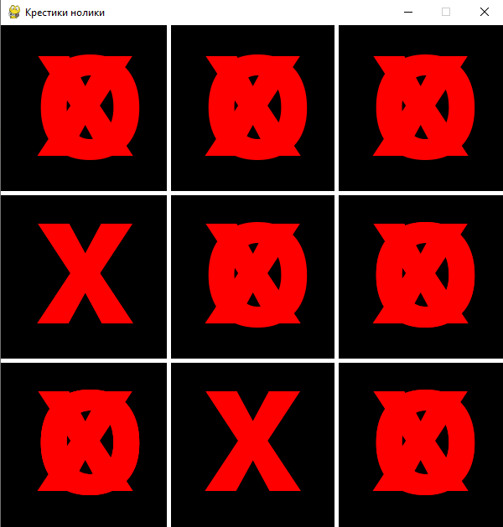Логическую проверку на крестик-нолик

F = True  
def draw_char(x, y):  
 global F  
 F = not F  
 char = 'o' if F else 'x'  
 x = x // 200 * 200 + 40  
 y = y // 200 * 200 - 20  
 char_render = font.render(char, True, 'red')  
 SCREEN.blit(char_render, (x , y ))  
 display.update()

Заполняем список значений

F = True  
lst = [[0,0,0] for i in range(3)]  
print(lst)  
def draw_char(x, y):  
 x = x // 200  
 y = y // 200  
 if not lst [y][x]:  
 global F  
 char = 'o' if F else 'x'  
 F = not F  
 lst [y][x] = char  
 print(lst)  
 x = x * 200 + 40  
 y = y * 200 - 20  
 char_render = font.render(char, True, 'red')  
 SCREEN.blit(char_render, (x , y ))  
 display.update()

Программируем проверку на победу:

from pygame import display, init, draw, event, MOUSEBUTTONDOWN, font, QUIT  
  
init()  
font.init()  
  
SIZE = (600, 600)  
  
SCREEN = display.set_mode(SIZE)  
display.set_caption("Крестики нолики")  
for x in (200,400):  
 draw.line(SCREEN, 'white', (x, 0), (x, 600), 5)  
 draw.line(SCREEN, 'white', (0, x), (600, x), 5)  
  
  
display.update()  
font = font.SysFont('Сourier New', 320)  
F = True  
lst = [[0, 0, 0] for i in range(3)]  
print(lst)  
  
def draw_char(x, y):  
 x = x // 200  
 y = y // 200  
 if not lst[y][x]:  
 global F  
 char = 'o' if F else 'x'  
 F = not F  
 lst[y][x] = char  
 print (is_win())  
 x = x * 200 + 40  
 y = y * 200 - 20  
 char_render = font.render(char, True, 'red')  
 SCREEN.blit(char_render, (x, y))  
 display.update()  
  
  
def is_win():  
 for row in lst:  
 res0 = [0 for i in row if i == 'o']  
 resX = [1 for i in row if i == 'x']  
 if (len(res0) == 3 or len(resX) == 3) and (all(res0) or all(resX)):  
 return 'win'  
 if lst[0][0] == lst[1][1] == lst[2][2] == 'x' or lst[0][0] == lst[1][1] == lst[2][2] == 'o':  
 return 'win'  
 if lst[0][2] == lst[1][1] == lst[2][0] == 'x' or lst[0][2] == lst[1][1] == lst[2][0] == 'o' :  
 return 'win'  
  
while True:  
 for e in event.get():  
 if e.type == QUIT:  
 exit()  
 if e.type == MOUSEBUTTONDOWN:  
 x, y = e.pos  
 draw_char(x, y)

Далее

import time  
  
from pygame import display, init, draw, event, MOUSEBUTTONDOWN, font, QUIT  
from random import randrange  
  
init()  
font.init()  
  
SIZE = (600, 600)  
  
SCREEN = display.set_mode(SIZE)  
display.set_caption("Крестики нолики")  
for x in (200, 400):  
 draw.line(SCREEN, 'white', (x, 0), (x, 600), 5)  
 draw.line(SCREEN, 'white', (0, x), (600, x), 5)  
  
display.update()  
font = font.SysFont('Сourier New', 320)  
F = True  
lst = [[0, 0, 0] for i in range(3)]  
print(lst)  
  
  
def user_make_step(x, y):  
 x = x // 200  
 y = y // 200  
 if not lst[y][x]:  
 lst[y][x] = 'x'  
 print(is_win())  
 render_char('x', x, y)  
 comp_make_step()  
  
  
def render_char(char, x, y):  
 x = x * 200 + 40  
 y = y * 200 - 20  
 char_render = font.render(char, True, 'red')  
 SCREEN.blit(char_render, (x, y))  
 display.update()  
  
  
def comp_make_step():  
 time.sleep(1)  
 lst0 = sum(lst, [])  
 lst0 = [i for i in lst0 if i]  
 if len(lst0) == 9:  
 print('Ничья')  
 return  
 while True:  
 x, y = randrange(3), randrange(3)  
 if lst[y][x] == 0:  
 lst[y][x] = 'o'  
 render_char('o', x, y)  
 break  
  
  
def is_win():  
 for row in lst:  
 res0 = [0 for i in row if i == 'o']  
 resX = [1 for i in row if i == 'x']  
 if (len(res0) == 3 or len(resX) == 3) and (all(res0) or all(resX)):  
 return 'win'  
 if lst[0][0] == lst[1][1] == lst[2][2] == 'x' or lst[0][0] == lst[1][1] == lst[2][2] == 'o':  
 return 'win'  
 if lst[0][2] == lst[1][1] == lst[2][0] == 'x' or lst[0][2] == lst[1][1] == lst[2][0] == 'o':  
 return 'win'  
  
  
while True:  
 for e in event.get():  
 if e.type == QUIT:  
 exit()  
 if e.type == MOUSEBUTTONDOWN:  
 x, y = e.pos  
 user_make_step(x, y)